Web app : cldvpoepart3-gpdue2fwgwhhhah0.southafricanorth-01.azurewebsites.net
YT: https://youtu.be/n8ZhSP6cYBI
Github: https://github.com/ZandreKoekemoer/cldv-part3-ST10445246

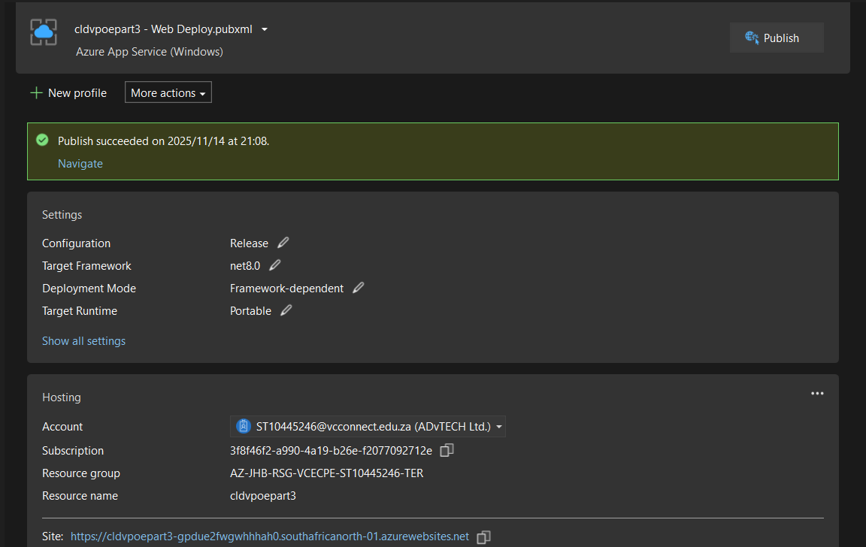

Section A
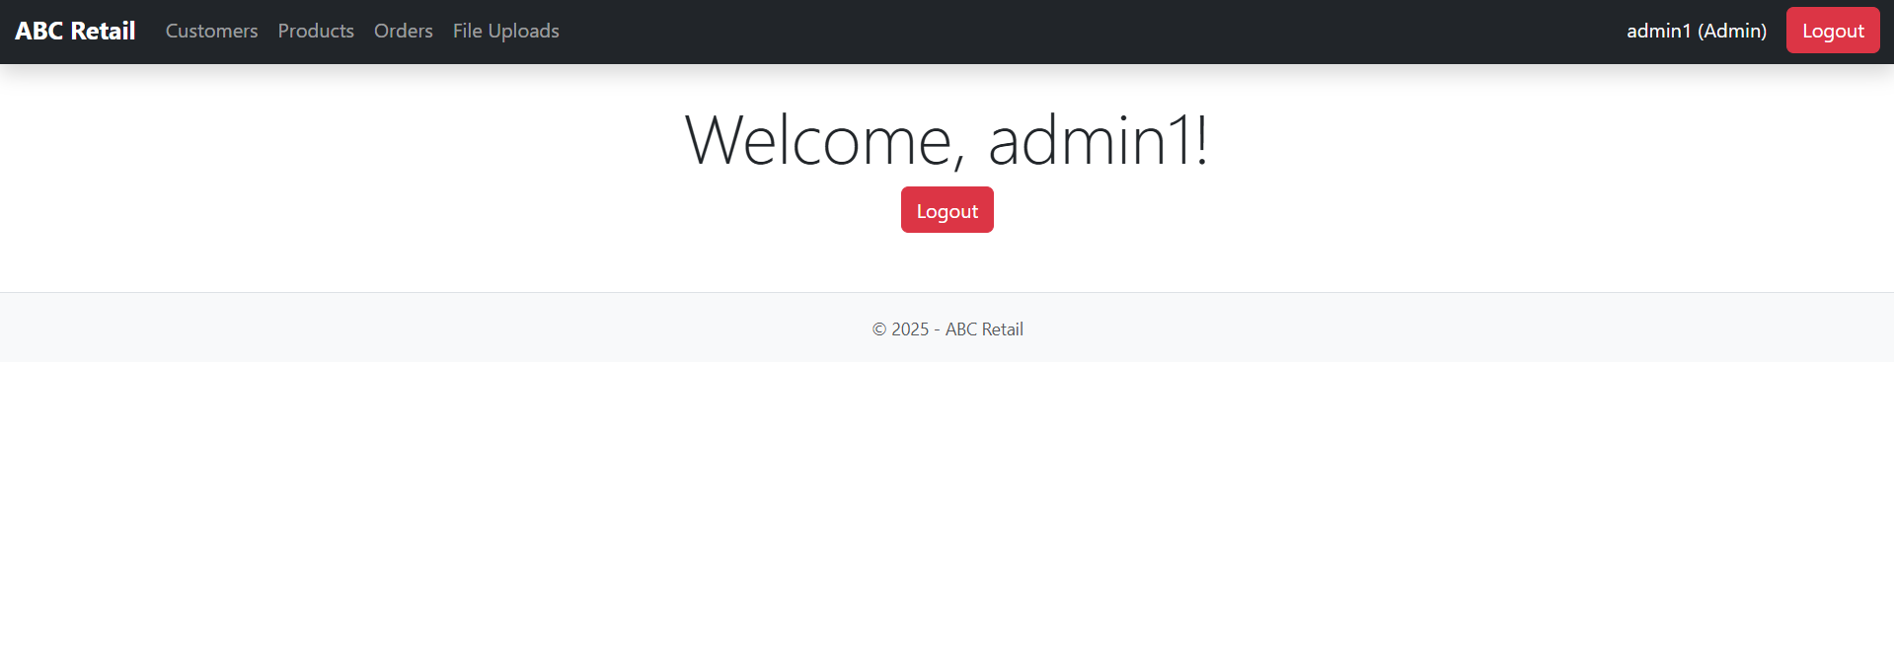
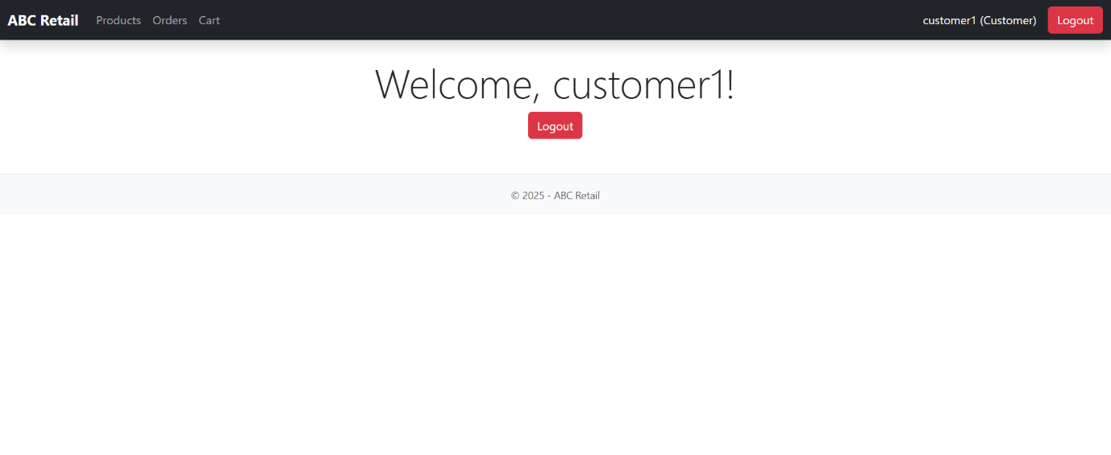

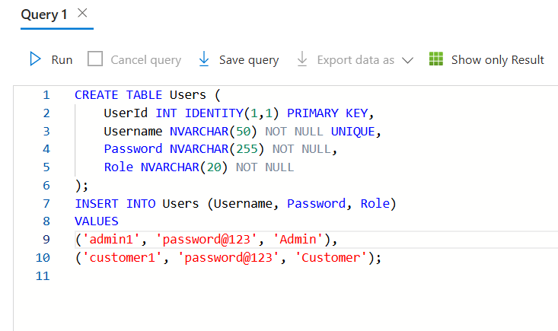

Section B
Component / Service | Technology Choice | Hosting Model
Azure App Service | Compute | PaaS
Azure Storage Account | Cloud Storage | PaaS
Azure Table Storage | NoSQL Datastore | PaaS
Azure Blob Storage | Object Storage | PaaS
Azure Queue Storage | Messaging | PaaS
Azure File Storage | Cloud File System | PaaS
Azure Functions | Serverless Compute | FaaS
Azure SQL Database | Relational Database | PaaS

Section C
Requirement 1: Storing Product Information
I wanted a place to keep all of the product information in my system, including the name, price, category, and description. (Jain, 2024) These are straightforward pieces of information that do not require complex relationships or joins. As a result, I selected Azure Table Storage. It's quick, inexpensive, and perfect for storing basic data. I like how it provides instant access, does not require a complicated setup, and is easy to scale. Because product information rarely changes, Table Storage is a useful way for keeping everything lightweight and neat and organized. (Jain, 2024)
Requirement 2: Uploading Product Photos
My system allows admins to upload product photos, and I wanted a place to store these images without slowing down the website. I used Azure Blob Storage since it is built to store large files, such as images. (Nanda, 2025) Blob Storage also provides public URLs for all submitted images, making it simple to display images of products directly on a website. This keeps my web server operating smoothly because the images are not loaded from the app itself, instead pulling them from Blob Storage, which is much more efficient. (Nanda, 2025)

Requirement 3: Saving Contract files
I needed to store documents such as contracts, PDFs, and any downloaded files that the admin may upload. I used Azure File Storage for this. It operates similarly to having a shared folder in the cloud. (Ignite, What is Azure Files?, 2025) I can simply upload and access files, and everything is stored in one spot. It is better suitable for document based files than Blob Storage since it operates as a structured file system. This keeps my documents away from the rest of my data, making them easier to manage or download as needed. (Ignite, What is Azure Files?, 2025)

Requirement 4: Managing Background Tasks and System Messages
There are some tasks in my app that shouldn’t run while the user is waiting. To keep my app responsive, I used Azure Queue Storage. This lets me put tasks into a queue and process them in the background later. (ScholarHat, 2025) Using queues makes the system smoother because the app doesn’t freeze or slow down when something more complex needs to happen behind the scenes. It also helps me separate the heavy tasks from the main web interface. (ScholarHat, 2025)

Requirement 5: Automated action using Azure functions
I wanted some actions in my app to run automatically when situations came up, such as when a file was uploaded or a message entered a queue. I used Azure Functions to handle this without having to always run a full server (fullscale, 2025). Azure Functions only execute when necessary, reducing costs and increasing system flexibility. They work well with Blob Storage, Table Storage, and Queue Storage, allowing me to run small amounts of code at the same moment something happens, such as updating data or processing a file. (fullscale, 2025)
Requirement 6: User Login and Role Management
My system requires safe login for both common customers and admin users. I wanted a solution that could securely store passwords, roles, and user information. (Learn, 2024) I used Azure SQL Database to accomplish this. It's dependable, completely managed, and offers strong security features. It provides encryption, firewalls, and strong relational structures, all of which are important when dealing with login data. (Learn, 2024)
Section D: Alternative Azure Technologies
For storing product information, instead of using Azure Table Storage, you could use Azure Cosmos DB. Cosmos DB is good because it works well around the world and can handle lots of data quickly. (Build5Nines, 2024)It’s better if you need fast access from different places or if your site gets a lot of people at once. It costs a bit more than Table Storage but lets you search and get information more effectively. (Build5Nines, 2024)

For uploading and showing product images, instead of Azure Blob Storage, you might use Azure Content Delivery Network with Blob Storage. (Ignite, 2025)A Content Delivery Network helps load images faster for people around the world by saving copies closer to them. (Ignite, 2025)
For Managing Background Tasks and System Messages, instead of using Azure Queue Storage to handle background tasks and system messages, you could use Azure Service Bus. (Ignite, 2025)This option is better for situations where you need to ensure messages arrive safely, handle them in a specific order, or manage more complex message routing. It’s good if you need more advanced message handling than just simple queues. (Ignite, 2025)

For Secure User Login and Role Management, instead of using Azure SQL Database for secure user login and managing roles, you could use Azure Active Directory. (Sztajno, 2025) This service simplifies user identity management and login processes without needing to handle a database of passwords. It also offers extra security features like two-step verification, social media logins, and single sign on. This makes it a great choice for applications that focus on secure user login. (Sztajno, 2025)

References
Build5Nines. 2024. How to Choose Between Azure Cosmos DB for Table and Azure Table Storage.[online] Available at:< https://build5nines.com/how-to-choose-between-azure-cosmos-db-for-table-and-azure-table-storage/#google_vignette > (Accessed 13 November 2025)
fullscale. 2025. What is Azure Functions and Its Advantages. [online] Available at:<https://fullscale.io/blog/azure-functions/ > (Accessed 13 November 2025)

Ignite, M. 2025. Azure App Service vs. Azure Blob Storage. [online] Available at:<https://learn.microsoft.com/en-us/answers/questions/2238512/azure-app-service-vs-azure-blob-storage-cdn-for-ho > (Accessed 13 November 2025)
Ignite, M. 2025. Storage queues and Service Bus queues - compared and contrasted. [online] Available at:<https://learn.microsoft.com/en-us/azure/service-bus-messaging/service-bus-azure-and-service-bus-queues-compared-contrasted> (Accessed 13 November 2025)
Ignite, M. 2025. What is Azure Files? [online] Available at:<https://learn.microsoft.com/en-us/azure/storage/files/storage-files-introduction> (Accessed 13 November 2025)
Jain, S. 2024. What is Azure Table Storage: Concept, Best Practices & Overview. [online] Available at:<https://cloudkeeda.com/azure-table-storage/ > (Accessed 13 November 2025)
Learn, M. 2024. An overview of Azure SQL Database and SQL Managed Instance security capabilities. [online] Available at:< https://learn.microsoft.com/en-us/azure/azure-sql/database/security-overview?view=azuresql > (Accessed 13 November 2025)
Nanda, A. 2025. Azure Blob Storage: How to Upload, Secure, and Manage Your Data. [online] Available at:<https://www.datacamp.com/tutorial/azure-blob-storage > (Accessed 13 November 2025)
ScholarHat. 2025. Queue Storage in Azure: Simple and Effective. [online] Available at:<https://www.scholarhat.com/tutorial/azure/queuer-storage-in-azure > (Accessed 13 November 2025)
Sztajno, M. (2025). Azure Active Directory authentication for SQL Server 2022. Retrieved from https://www.microsoft.com/en-us/sql-server/blog/2022/07/28/azure-active-directory-authentication-for-sql-server-2022/?msockid=2fc8185ba3d563f718460c71a24b6228 > (Accessed 13 November 2025)

